 | Amit Arvind Pise
 | B2B Sales Professional
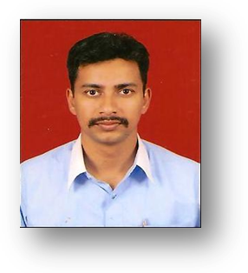 | Flat No-77, Sneha Housing Society,  Mhada Complex, karve Nagar,  Pune  +919762167579  amit.a.pise@gmail.com  D.O.B - 25th of March 1982

Objectives
Seeking a very high growth and challenging position in B2B sales where I can leverage my engineering acumen as well as my excellent interpersonal skills.
Education
D.I.C.E.R, Pune [affiliated to Pune University]
July 2010
MBA in Marketing, 60%

D.Y.P.I.E.T, Pune [affiliated to Pune University]
July 2008
BE in Instrumentation & Control, 64%
experience
Sales Engineer |LPS Bossard Pvt Ltd
From Feb 2012 to Date
- Handling four prime customers having a monthly turnover of more than 60 lacs with there new development, Schedules, Quality ,Engineering,payment collection etc
- Creating New Major Accounts for Fastners as well as there other C –part requirements .
- Making budgets for customer and achieving the set targets .
- Engineering solutions which will help customers to optimize there fastner requirement

Executive Sales – Hazel Infotech Pvt .Ltd.
From Dec 2011 to Feb 2012
- Making cold calls.
- Doing two demos a day of excise and export documentation software .
- Closing the deal after the demo .

Executive-Sales Zensar Technologies ltd. |
Dec 2010 – Aug 2011
- Generating Database, Identifying prospects.
- Making cold calls.
- Arranging demo’s of our hosted ERP solution.
- Arranging meetings for AVP and RSM with CIO, CEO, CFO .
Internship
Nokia Solution Specialist| CPM India
May2009 – June 2009
Customer Satisfaction Survey of Nokia N97
- Demonstration of the handset to company generated leads.
- Converting the hot leads to sales by the way of negotiations.
- Achieving sales targets.
- Providing services to the customer after the sales.

Achivements
- Won the sixth position in the event BIZ –MAZE at MMC’s Institute of Management, Education, Research & Training.
- Won the first prize in project competition held at VIT in 2008.
- Won the first prize in project competition held at MIT in 2008.
- Won the first prize in project competition held at DYPIET in 2008.
co-curricular activity
- Event Co-ordinator of National Seminar on Recession held in the college.
- General Secretary for DICER heading a group 240 students.
- Represented D.I.C.E.R. in various intercollegiate events .
TECHNICAL KNOWLEDGE
- PLC Programming done at GPP for Allen Bradley PLC in Sept 2006.
- C-Programming in April 2007 from Naralkar Institute.
- Post Graduate Diploma in Industrial Automation from VIT.

